WEB DEVELOPMENT Activity-Based Learning:

1. College Information and Admissions Website

AIM: Design a college website displaying institutional information, departments, courses, faculty profiles, admissions procedures, campus facilities, events, and contact details. Create a navigation bar, banner, and responsive information cards.

OUTPUT :

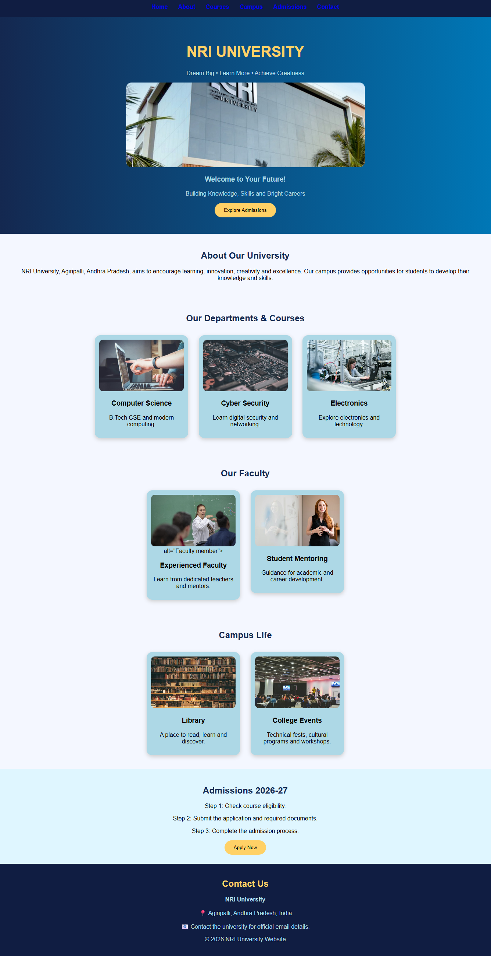

2. Online Shopping Website :

AIM: Create an e-commerce interface displaying products, prices, discounts, ratings, categories, product descriptions, and shopping buttons. Design a responsive product grid, promotional banners, and a shopping navigation bar.

OUTPUT:

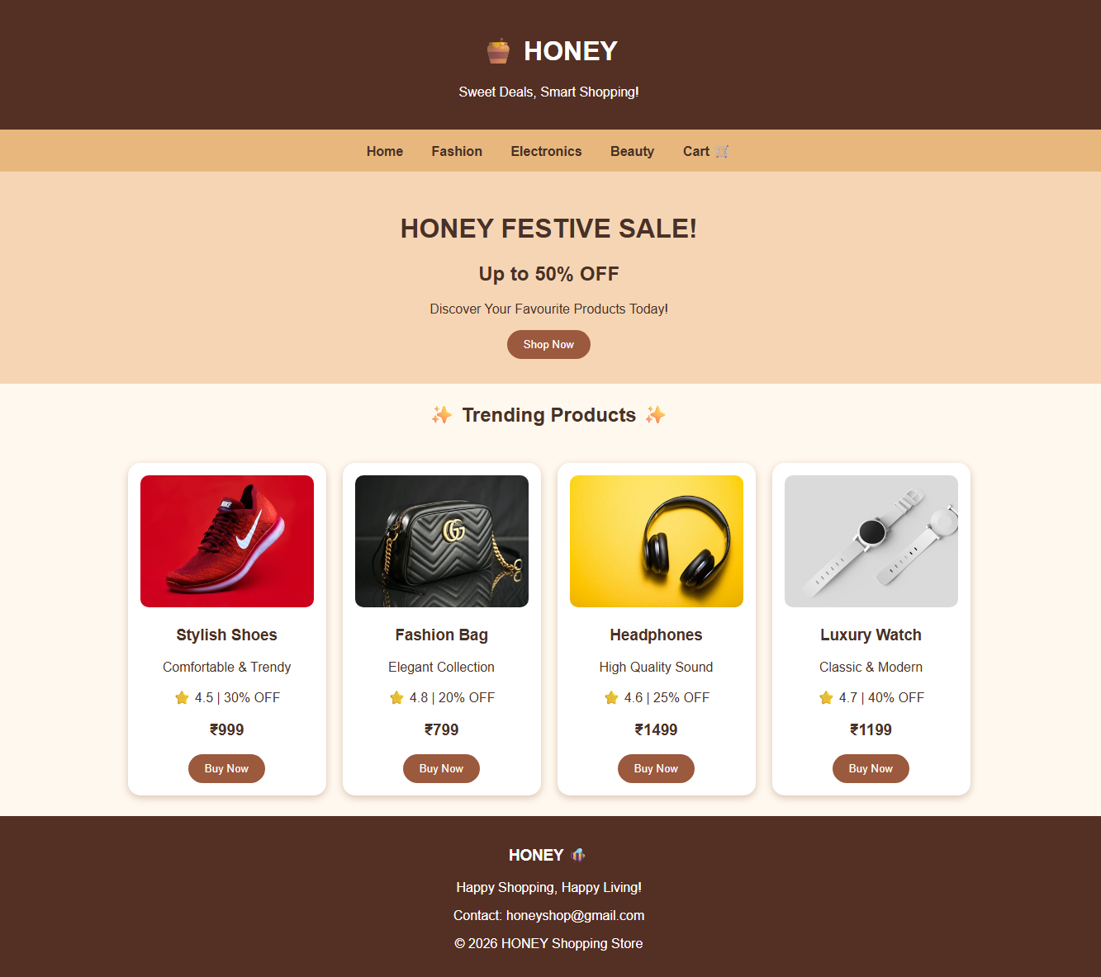

3. College Fest Management Website:

AIM: Build a college festival website displaying technical events, cultural competitions, workshops, schedules, event coordinators, rules, and registration forms. Use category-based cards and responsive event banners.
OUTPUT:


